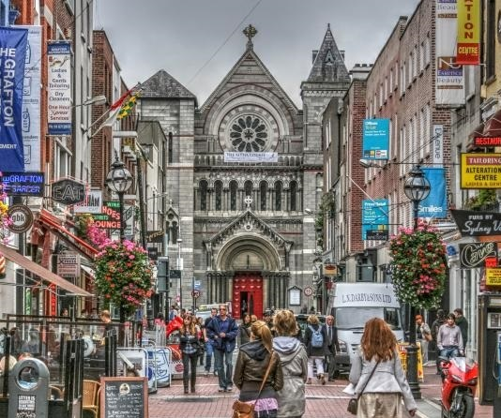
Grafton Street and Molly Malone
By Emma and Laura

- On the Irish trip, we are going to visit Grafton Street :

Grafton Street is a commercial and popular street, it is situated between Temple Bar and Trinity College. There are small businesses, different shops. There are food stores, clothes shops, there are popular brands and shoe shops…
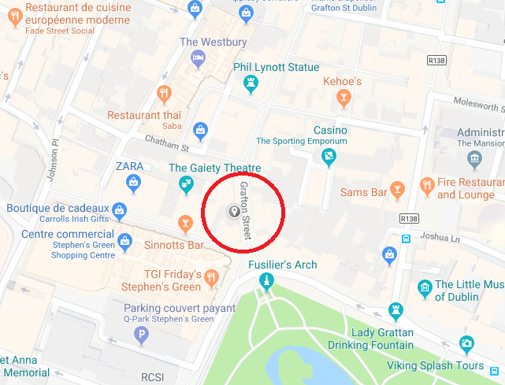

Grafton Street was established in 1708 by the Dawsons, a wealthy Dublin family. The street was named after Henry Fitzroy, the first Duke of Grafton.
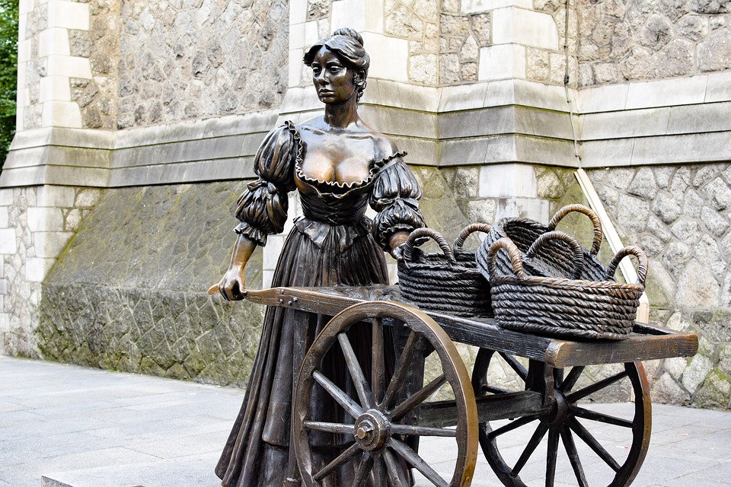
There is the Molly Malone statue, it was erected on the corner of Grafton Street and Suffolk Street and was unveiled at the 1988 Dublin Millennium celebrations. The famous statue at the bottom of Grafton Street is the perfect spot to take a photograph while taking in the atmosphere of the Grafton Street area. Another famous bronze statue in the Grafton Street area is that of Thin Lizzy lead singer and bassist Phil Lynott, the statue of the ‘Boys are Back in Town’ singer was unveiled in August 2005.

- And we are going to see The Molly Malone Statue :

Molly Malone was a fishmonger in Dublin in 1699, she was a beautiful woman, there is a popular song about her “Cockles and mussels”. She was a mysterious woman because, she had a tragic and sad life. After, she became a prostitute, her nickname was “The Prostitute with the cart”.

