Nature Day by Angie and Lou

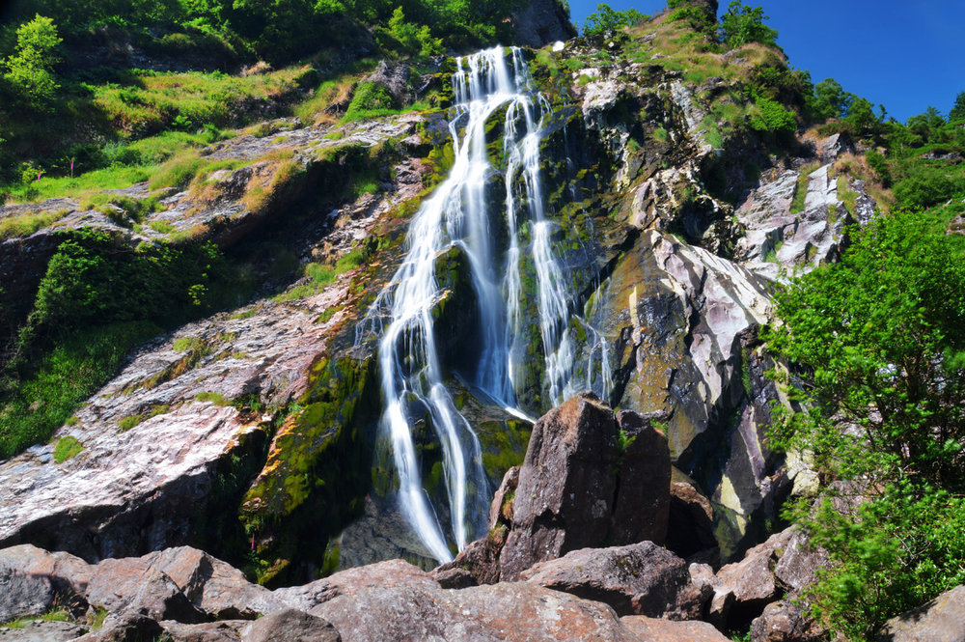
- Powerscourt waterfalls :
The waterfalls in Powerscourt is located in the country of Wicklow in Ireland. It is the highest waterfalls in Ireland with 121 meters. It is located in the upper Dargle river in the Wicklow mountains. It is part of the Powerscourt property. The movie Excalibur was shot there.
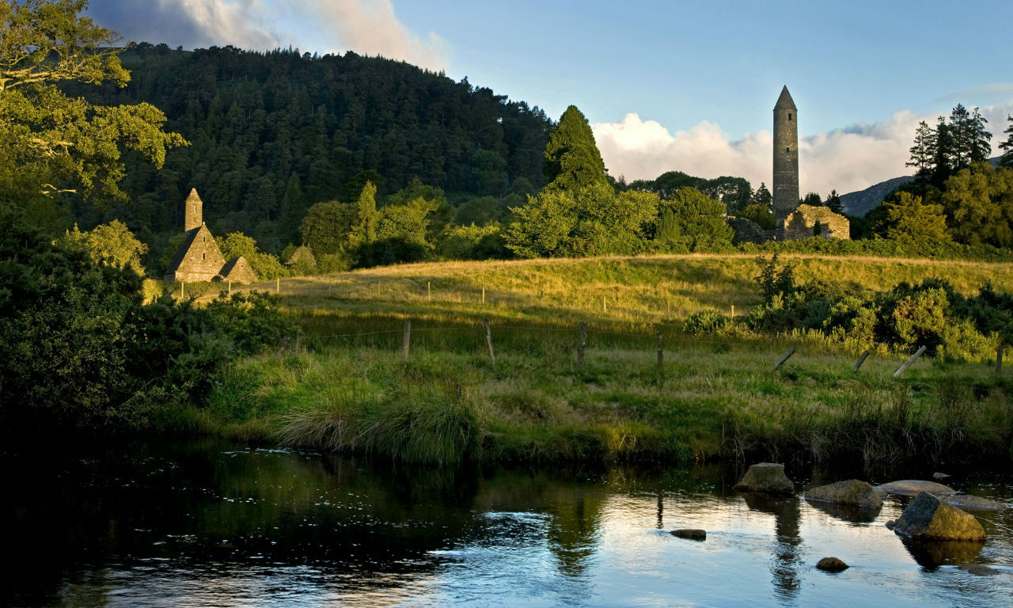
- Glendalough :
The visit of Glendalough is exceptional.
In Glendalough we can admire :
- a round tower of 33 meters ,it dates back from the 11th century.
- a cathedral dating back from the 12th century.

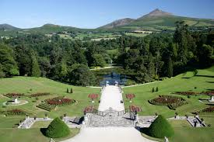
- Explore the Garden of Ireland :
The Powerscourt Gardens in the County of Wicklow is one of the most beautiful gardens in Ireland, 3 in the World’s Top Ten Gardens by National Geographic! The Gardens stretch over 47 acres and offer visitors a sublime blend of formal gardens, sweeping terraces, statues and ornamental lakes, secret hollows and rambling walks. Powerscourt Gardens were designed in 1731. The Powerscourt Gardens include The Walled Gardens, The Italian Garden, The Dolphin Pond, The Japanese Gardens, Pets Cemetery and the Pepperpot Tower.


