**THE EMERALD ISLE**

**Observe the map and locate Dublin, the Wicklow County and Glendalough :**

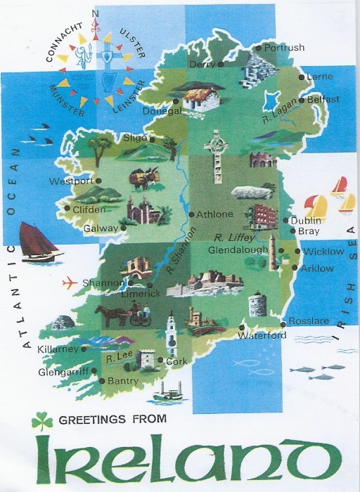

**Complete the questionnaire :**

Ireland is an ……………………….. divided into ………. Territories : the British Northern Ireland called ………………….. and the Republic of Ireland called ………….. There are …………. capital cities : ……………….. in the north and ………….. in the south.

**Discover Ireland’s history :**

* The Vikings occupied Ireland in the early centuries
* In ……………….., the British invaded Ireland and good lands were given to William the Conqueror’s Norman Army
* In 1649, the conflict between the Catholics and the Protestants began
* The Act of Union in 1800 united Ireland to England
* From 1845 to …………….., there was the Great Potatoe Famine, a lot of Irish people died or emigrated especially to the USA
* From …………….. to …………………, a law called Home Rule Bill was passed but it was a tragedy for some Irish people because they wanted to become independent.
* In 1916, during the « Easter Rising » a Republic was declared in Dublin but it was not a success… The IRA ( Irish Republican Army) was born and began a terrorist war
* In 1921, London decided to divide Ireland into 2 territories : a ……………….. one and an …………………………. one. Eire was born in …………………

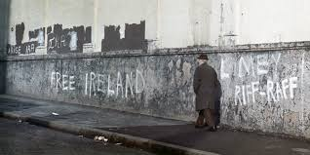

* In the ………………., the IRA led a terrorist campaign in London and a lot of their leaders were imprisonned and tortured

The living conditions in the North of England were difficult with a lot of discrimination in terms of jobs, education or housing.

On ………………… ………….. 1972, the IRA detonated 20 bombs across Belfast in 75 minutes. 130 people were mutilated and 13 Catholics were killed during a demonstration : it was called « the Bloody Sunday » (details in U2’s song)

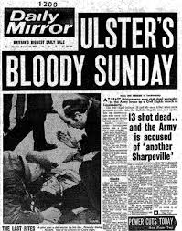

* In 1994, the IRA with Gerry Adams announced a ceasefire but in ……….., 2 bombs exploded in Manchester and in London and there was the Dunblane Massacre. 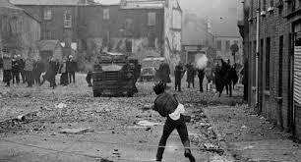
* « The Good Friday Agreement » in ……………….. promised political stability and peace

The conflict in Northern Ireland from 1968 to 1998 is known as «  …….. ……………………………..  » Over …………………. people were killed and thousands were injured.

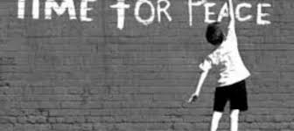

**Some facts about Ireland :**

The Irish flag is highly symbolical with its ………. colors

There are …...... million inhabitants in Ireland and the Irish population is very ……………

The National Holiday is ………………….. ………………………’s Day ; it is celebrated on ………………… …………. every year

There are different Irish symbols such as the ……………………….. or the ………… and there are legendary creatures named the ……………………….

**Discover the city of Dublin :**

Dublin’s river is called ....... …………… and you can fun on it on the «  ………

Splash Tour »

If you travel to Dublin, you MUST see or visit :

* ……………………. ……………………….. , the oldest university in Ireland, founded in 1592
* ………. ……………….. of Kells, a golden and sacred Celtic book
* …………………. ………….. where you can admire beautiful pubs and live music
* Museums like the National Archeological and History Museum to know more about Ireland’s History
* …………………… Street is where the statue of ………….. ………………. (she was a fishmonger and a prostitute who had a short but tragic life) It is the shopping district too ! Nassau Street is also a popular street !
* Parks like St ……………………’s Green or Phoenix Park where Dubliners can relax
* Colored doors which are a typical architectural design for Dublin

