TEMPLE BAR by Alice and Lucile

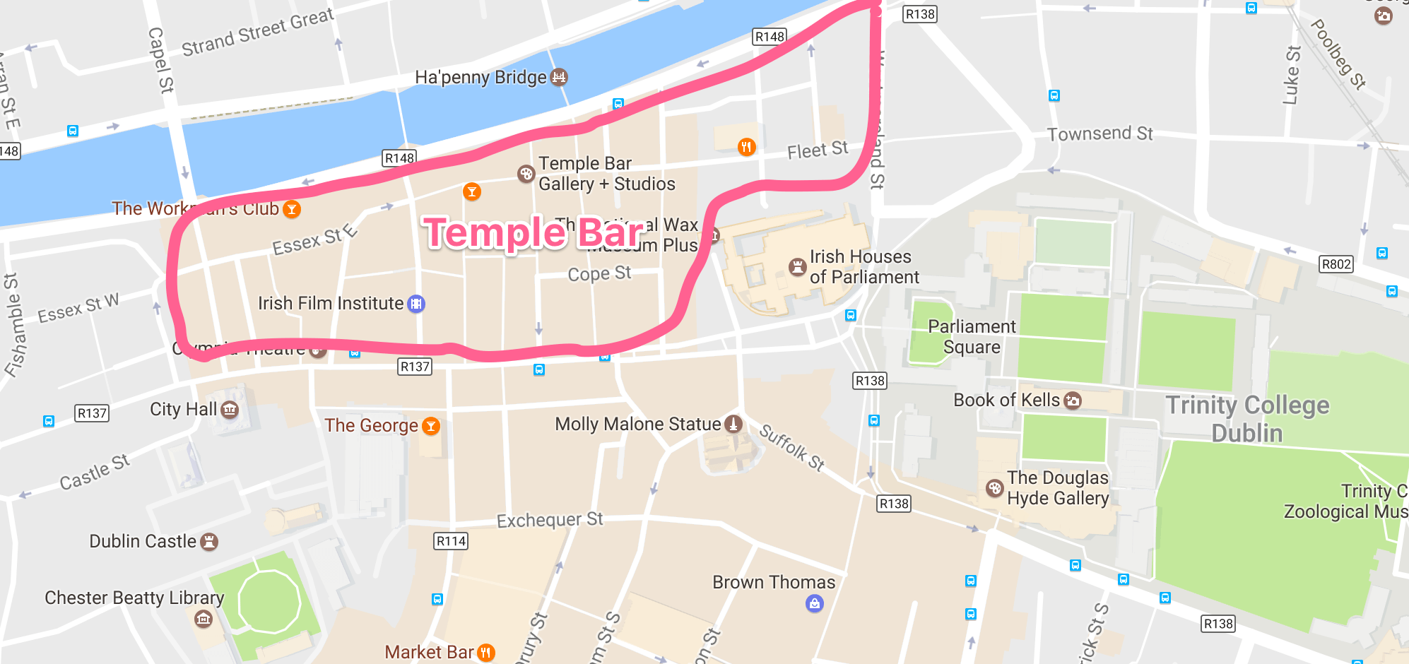
Temple Bar is a quarter of the historic center of Dublin, situated on the south shore of the Liffey. It's famous for its night life, and there are many musicians in the street.

Its name comes from William TEMPLE (who was vice-chancellor of Trinity College) because this man built houses along the street called the Bar.
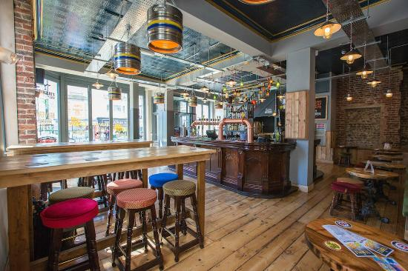
There is a lot of little streets where we can find pubs, bars, shops and restaurants.
The most famous pub is " The Temple Bar ". We can find Irish gifts and souvenirs in the "Temple Bar Trading Company ".


