**NEW YORK 2019**

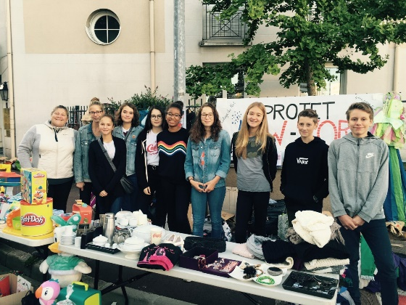 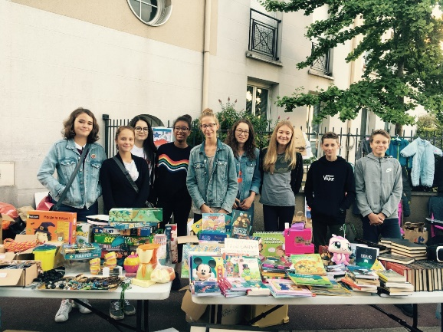

Hello everyone,

We are a group of 36 teenagers, aged 13-14 and our English and PE teachers are planning to take us on a 1 week-schooltrip to NYC in May 2019 ! We are not sure about the date of our arrival (still waiting for the best airfare deals) though our stay should be scheduled within the last 15 days of May.

Our school is located in the Southern suburbs of Paris, in Sucy en Brie.

We are eager to discover the Big Apple and we started working on saving money organizing Loto nights and garage sales (see our pictures above !) We really want to improve on our communication skills so we would be thrilled to find and stay with American host families ! We are thinking of spending 7 nights with our hosts. Since our days in the city will be intense, we want to ask families to provide us with food for breakfast and dinner !

If you need more information, you can contact our English teacher Miss HERRY by mail [Delphine.Herry@ac-creteil.fr](mailto:Delphine.Herry@ac-creteil.fr) or by phone 01133661409521

We are excitingly looking forward to hearing from you

The Collège du Fort students